# Lab 04

## Index

The lab says 'Module 3: Building model-driven apps' but it is placed after 'Module 4: Building canvas apps'. Is this the right order?

## Exercise 3 Task 1 Step 6

Added note as sometimes the next stage button is not visible on the app and requires a refresh.

# Lab 03

## Exercise 1 Task 1 Step 12

I added this step as just an FYI because in some cases, students thought it was loading something and they waited for more than just a few minutes.

## Exercise 1 Task 2 Step 10

When the Save As operation is completed, then the browser window is refreshed, which removes the Back button. Updating the step to use Back button in the browser.

## Exercise 1 Task 3 Step 5

The canvas app editor is already opened when saving the Component library so it will not ask again for country and get started, Instead the skip option will come.

## Exercise 1 Task 3 Step 17

When the component is added on the screen, the default height cuts-off a little text to adding an step to set the proper height. Added image37.png in the resources.

## Exercise 1 Task 3 Step 26

Added a save step to ensure that the progress is saved before moving onto the next exercise. This way if any student is taking a break before next exercise, then they are saving the app to avoid any issues.

## Exercise 4 Task 1 Step 16-18

Moving the NewForm expression to the OnSuccess property so the form mode is only changed when it is successful and the error will show in case of any invalid values.

## Exercise 5 Task 1 Step 7

Fixed the typo and updated the screenshot.

## Exercise 4 Task 1 Step 22

The app is not published and this is the last task before integration, so added a step for Publish.

## Exercise 7 Task 2 Step 2

The step was just to double click Form Screen and no other actions so I removed it.

## Exercise 7 Task 3 Step 22

Until this point, only one record has the supporting data, so the icons for Next and Back are disabled. I am adding a few steps to add records so that the Next and Back button are enabled while testing.

# Lab 02

## Error while creating Publisher.

The added Choice value prefix is not accepted. 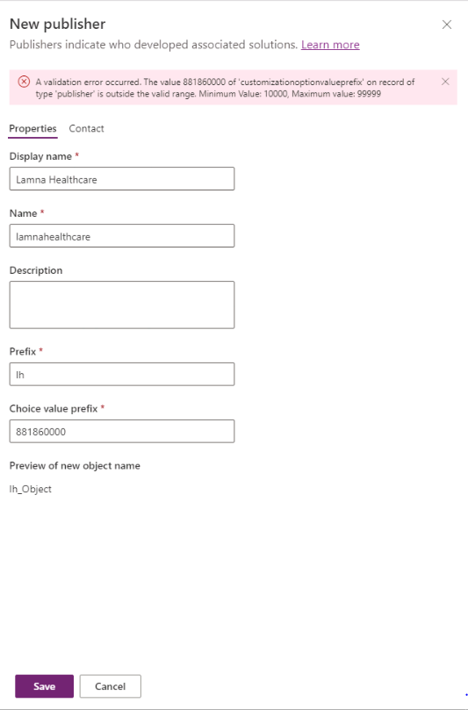

Also, changing the screenshot to Image105.png.

## Image Addition on Exercise 2 Task 1 Step 7

Adding this screenshot on the screen will be helpful for beginners to understand the navigation and it will not be needed on any further step. I added a screenshot named as Image99.png

## Exercise 3 Task 1 Step 17

The default status is selected as New but as per the screenshot it is set to Assigned. I added a new screenshot as Image100.png

## Exercise 3 Task 1 Step 21

The default status is selected as New but as per the screenshot it is set to Assigned. I added a new screenshot as Image101.png

## Exercise 3 Task 3 Step 9

The screen is refreshed and there is no <- Back option available. Instead of this, the browser back button can be used.

## Exercise 4 Task 1 Step 6

By default, the Pages menu is opened, a step for switching to Navigation is added. Added screenshot Image102.png

## Exercise 4 Task 1 Step 13

The popup for save and publish is appearing even though the changes the saved. So added a step for this one. Added screenshot Image103.png

## Exercise 4 Task 1 Step 27

After creating Buildings sub area, there is no sub area on the app. Also, on step 28 we are adding subarea under Taxonomy group, so this step is not needed.

## Exercise 4 Task 1 Step 32

As the app is refreshed once the app is reloaded after adding second area. So added step to close the browser and navigation to Solutions again.

## Exercise 6 Task 2 Step 3

It takes the users to first experience. Adding the step to reopen the flow. URL: <https://us.flow.microsoft.com/en-us/?showFirstRunExperience=true>

## Exercise 6 Task 3 Step 3

My Reports View does not exist yet. It is created in the next module. Changing the step to existing view and also adding a screenshot Image104.png

# Lab 00

## Exercise 1 Task 1 Step 7

It is invalid as there is no Start button. The screen which is displayed asks for region and phone number and then the button text is “Get Started”.

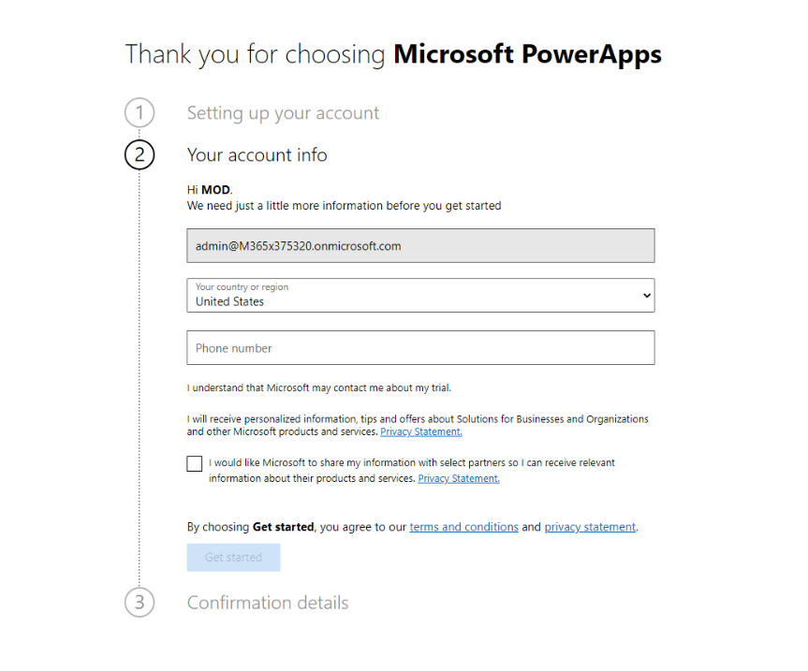

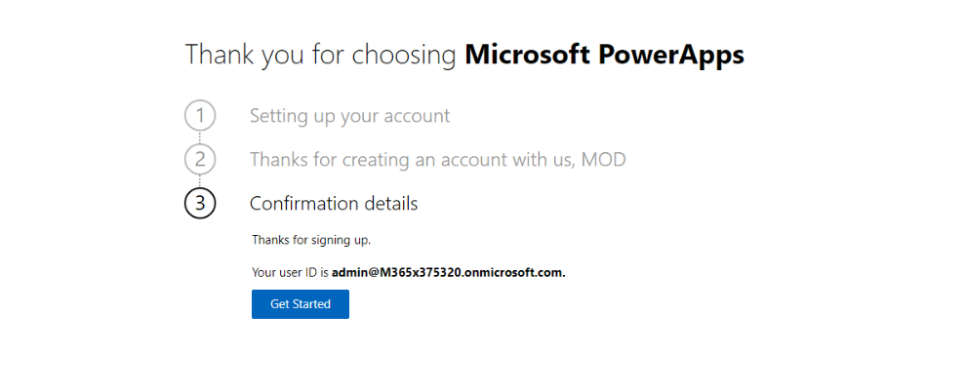

## Exercise 1 Error:

Error while activating the license. When the exercise 1 is completed, after that the message shows on the screen as “Sorry, there has been a disconnect”. Usually the license is assigned, but some students need to repeat the steps. We can add an additional step where students having these issues can troubleshoot, while other students can go to the next exercise.

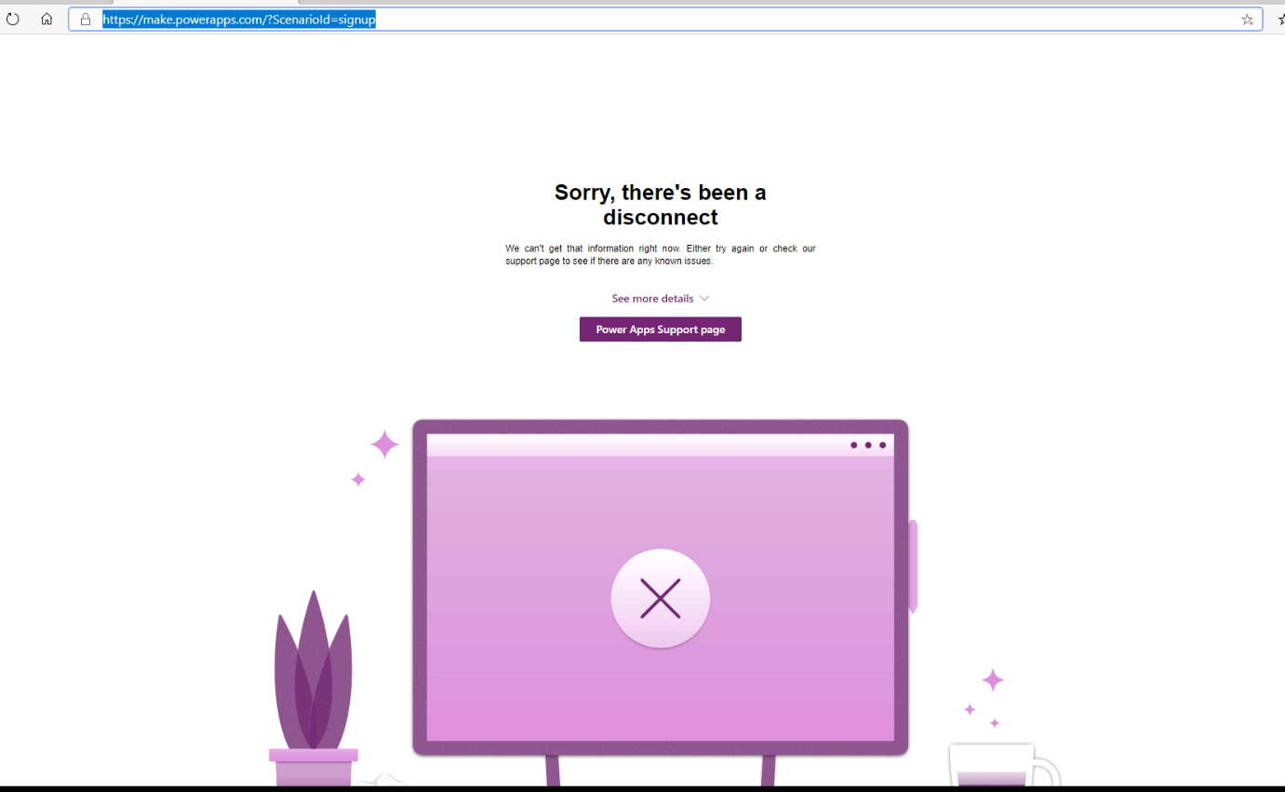

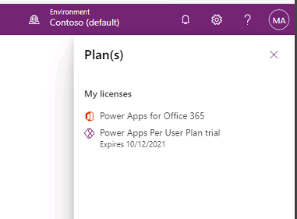

## Exercise 2

Enable Sample Apps and Data option. There are some in between the module exercises, where this sample data is required. This is aligned with Skill pipe book. In some of those exercises, it asks the user to observe the Sample Model Driven Apps which are auto-created with this option.